

POWER BI PRJECT REPORT

FOOD DELIVERY OPERATIONS ANALYTICS
Using Business Intelligence and Microsoft Power BI
Analysis of songs, artists, popularity, duration and album characteristics

PROJECT DETAILS
Student Name | VEDANT MISHRA
Roll / Enrollment No. | BV25-AI-14
Department | B.Voc. Artificial Intelligence
Academic Year | 2026-2027
Primary Tool | Microsoft Power BI
Project Domain | Spotify Music Analytics

CERTIFICATE

This is to certify that Vedant Mishra , Roll / Enrollment No. BV25-AI-14, of B.Voc. Data Science, has completed the project titled “FOOD DELIVERY OPERATIONS ANALYTICS using Microsoft Power BI”during the academic year 2026-2027 under academic guidance.

The project demonstrates the application of Business Intelligence techniques to explore a Spotify music dataset through song and artist analysis, popularity comparisons, duration measures, album-type distribution, explicit-content classification and chart-position indicators. The report documents the use of Microsoft Power BI for measures, visualizations and interactive filtering.
The work is submitted as part of the academic requirements of the programme.

Place | Date | Project Guide / Faculty Signature

DECLARATION

I, Vedant Mishra, declare that this project report entitled “FOOD DELIVERY OPERATIONS ANALYTICSusing Microsoft Power BI” is prepared as my academic work for the B.Voc. Data Science programme during the academic year 2026–2027.

The project uses an interactive Power BI report to examine songs, artists, popularity, duration, album types, explicit and non-explicit tracks, and chart positions. The descriptions of visuals and measures are based on the supplied Spotify Dashboard.pbix file. Numerical findings are not stated as facts unless they can be verified from the live report or underlying data.

Student Signature: Name: Vedant Mishra
Date:

ABSTRACT

This project develops a FOOD DELIVERY OPERATIONS ANALYTICS report using Microsoft Power BI. The report is designed to explore a music chart dataset by examining songs, artists, popularity, duration, album type, explicit-content classification and chart position. The supplied PBIX contains four report pages: Home, Overview, Artist and Songs.
The Overview page includes cards and charts for distinct songs, average popularity, average duration, song distribution by album type, explicit versus non-explicit songs, songs by year, popularity by album type and comparisons involving artists and songs. The Artist page focuses on songs and popularity by artist, first-position achievements and artist-level details.

The Songs page provides song-focused popularity and artist comparisons, alongside detail tables and navigation controls.
The project demonstrates the use of Power BI visualizations, DAX measures and interactive report navigation. The underlying DAX query included in the project defines measures such as Total Songs, Distinct Songs, Distinct Artists, Avg Popularity,

Avg Duration Minutes, Explicit Songs, Non-Explicit Songs, Avg Position and Position 1 Songs. Exact totals and rankings should be read from the refreshed report because they may depend on the data and active filters.

Keywords: Power BI, Spotify, Music Analytics, Data Visualization, DAX, Song Popularity, Artist Analysis, Explicit Content, Business Intelligence.

TABLE OF CONTENTS

Section | Contents
Preliminary pages | Certificate, Declaration, Abstract
Chapter 1 | Introduction (Background, Problem Statement, Aim, Objectives, Scope)
Chapter 2 | Dataset and Business Requirements
Chapter 3 | Tools and Technologies
Chapter 4 | Data Preparation and Data Model
Chapter 5 | DAX Measures and KPI Framework
Chapter 6 | Dashboard Development
Chapter 7 | Analytical Findings
Chapter 8 | Recommendations
Chapter 9 | Testing and Validation
Chapter 10 | Limitations and Future Scope
Chapter 11 | Conclusion
References | Sources and documentation
Data and Interpretation Note | Guidance on reading results
Appendix A | Dataset Profile and Key Results
Appendix B | DAX Measures
Appendix C | Power Query and Model Screenshots
Appendix D | Dashboard Screenshots
Appendix E | Dataset Profiles, DAX Code, Model & Dashboard Interface Specs

CHAPTER 1 INTRODUCTION

Background
The rapid growth of metropolitan commercial centers, combined with high smartphone penetration and digital payment adoption, has transformed urban food retail. Hyper-local delivery platforms such as Zomato process thousands of concurrent order requests across complex city infrastructures. The financial viability of last-mile logistics networks depends directly on fulfillment velocity, route efficiency, fleet utilization, and customer satisfaction.
Fulfillment operations take place in highly dynamic environments shaped by unpredictable external variables. Delivery couriers navigate fluctuating traffic congestion, changing weather conditions, varying transit distances between restaurants and drop-off points, and complex multi-order batching assignments. Modern logistics platforms require enterprise Business Intelligence (BI) systems to aggregate operational logs into structured tabular data models. These systems allow decision-makers to evaluate performance indicators, detect bottlenecks, allocate fleet resources effectively, and reduce delivery delays. Microsoft Power BI Desktop provides an enterprise analytics environment that integrates data preparation, tabular data modeling, Data Analysis Expressions (DAX), and interactive visual dashboards.

Problem Statement
Reviewing raw, unstructured food delivery logs in flat spreadsheets presents major operational challenges. High tabular data density makes it difficult for logistics operational managers to detect dispatch bottlenecks, evaluate spatial delivery performance across municipal zones, or isolate the compounding delays caused by severe traffic congestion and adverse weather. Without aggregated KPI frameworks and interactive visual reporting tools, organizations struggle to evaluate fleet vehicle performance, establish realistic estimated time of arrival (ETA) models, or assess the operational impact of multi-order courier assignments.
This operational opacity leads to inefficient courier dispatching, inaccurate customer delivery windows, courier fatigue, and increased order cancellation rates. Establishing an interactive BI analytics solution is essential to transform raw operational data into dynamic dashboards. This enables real-time filtering across municipal regions, weather conditions, traffic densities, and vehicle types, supporting data-driven last-mile logistics management.

Aim

To design, model, and deploy an interactive food delivery operations analytics application using Microsoft Power BI Desktop, utilizing the Zomato delivery dataset to evaluate fulfillment latency drivers, spatial distance patterns, environmental bottlenecks, and fleet allocation performance.

Objectives

1. ETL Engineering: Perform data extraction, auditing, transformation, and semantic modeling within Power BI Desktop on the Zomato food delivery dataset.
2. DAX Formulation: Formulate robust DAX calculations for core metrics including total order volume, average delivery duration, spatial distance, courier ratings, and transit velocity.
3. Executive Overview: Develop an executive Overview dashboard reporting macro-level operational KPIs, traffic bottlenecks, weather impacts, and regional order distributions.
4. Operational Analysis: Construct an Operation Analysis dashboard dissecting fulfillment performance across vehicle types, order categories, festival periods, and multi-delivery loads.
5. Performance Tracking: Design a Delivery Performance reporting page integrating temporal delivery trends, rating correlation scatter analyses, regional distance patterns, and detailed order inspection grids.
6. Dynamic Interactivity: Implement interactive slicers and dynamic cross-filtering controls across all dashboard views.
7. Empirical Findings: Provide empirical analysis of operational bottlenecks to formulate actionable recommendations for last-mile logistics optimization.
8. Validation & Governance: Establish formal testing protocols, document DAX measure code repositories, and outline analytical limitations to support scalable BI deployment.

Scope and Business Questions

The scope of this study is defined by the schema structures, analytical measures, and visualization component
embedded within the Power BI project file (food_Delivery_Operations_Analytics.pbix). The analytical boundaries address
key operational efficiency challenges across last-mile delivery networks:
• Baseline Metrics: What is the baseline order volume, average delivery duration, and spatial coverage distance across the operational network?
• Environmental Bottlenecks: How severely do environmental weather conditions and road traffic density impair last-mile fulfillment speed?
• Spatial Distribution: What is the spatial distribution of order volume across Metropolitan, Urban, and Semi-Urban municipal zones?
• Fleet Efficiency: Do specific vehicle types (motorcycles, scooters, electric scooters) deliver superior fulfillment times in dense urban traffic?
• Workload Stacking: How does assigning multiple concurrent deliveries to a single courier impact total order delivery duration?
• Category Dissection: Does order item classification (Snack, Meal, Drinks, Buffet) significantly affect prep and fulfillment latency?
• Distance Dynamics: What spatial distance patterns emerge across different municipal city classifications?
• Quality Correlations: How do total delivery durations correlate with customer feedback ratings assigned to couriers?

CHAPTER 2 DATASET AND BUSINESS REQUIREMENTS

2.1 Dataset Overview
The project is built upon the Zomato Food Delivery Operations dataset, represented within Power BI Desktop as a primary data entity named Deliveries. The dataset captures order fulfillment logs from hyper-local food deliveries, recording spatial coordinates, timestamped events, courier demographics, environmental conditions, vehicle classifications, and final delivery durations.
The primary data entity Deliveries comprises 38,964 distinct order records recorded between February 11, 2022, and April 06, 2022. The spatial coverage represents a total calculated delivery distance of 380,497.65 kilometers across diverse urban regions. The dataset includes key metrics such as unique order identifiers (ID), courier attributes (Delivery_person_ID, Delivery_person_Age, Delivery_person_Ratings), spatial geographical coordinates (Restaurant_latitude, Restaurant_longitude, Delivery_location_latitude, Delivery_location_longitude, distance_km), temporal markers (Order_Date, Time_Ordered, Time_Order_picked), environmental context (Weather_conditions, Road_traffic_density), operational attributes (Type_of_vehicle, Type_of_order, multiple_deliveries, Festival, City), and the target fulfillment latency measure (Time_taken (min)).

Data Fields

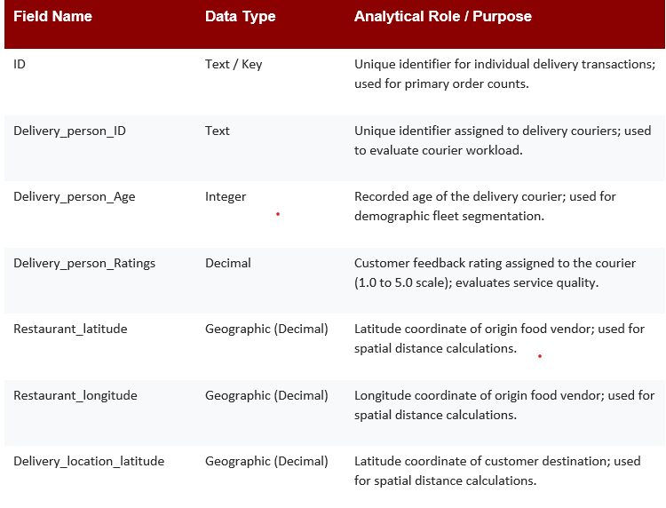

Business Requirements

- Present a concise overview of song and artist metrics.
- Compare songs and popularity by artist.
- Show song popularity comparisons.
- Analyze album-type distribution and explicit-content categories.
- Explore year-related song distribution.
- Provide detailed artist- and song-focused report pages.
- Support navigation between Home, Overview, Artist and Songs pages.
- Ensure calculations and filter behavior are validated before final conclusions are reported.

CHAPTER 3 TOOLS AND TECHNOLOGIES

Tool / Component | Purpose
Microsoft Power BI Desktop | Create report pages, visualizations, measures and navigation.
Power Query Editor | Inspect source tables, column types, missing values and transformations.
DAX | Create reusable calculations for counts, averages, maxima, minima and filtered subsets.
Data model | Organize the source table and measure definitions for report calculations.
Power BI visualizations | Present data through cards, bar charts, area charts, donut charts and tables.
Slicers and page navigation | Filter report content and move between report pages.

Why Power BI?
Power BI was selected because it allows the dataset to be explored interactively. Measures can be reused across visuals, and filters can narrow the view to selected songs, artists, years or categories when those fields are available in the report.

Dashboard Design Principles
    - Clarity: use descriptive visual titles and readable labels.
    - Comparability: use consistent measures when comparing songs or artists.
    - Interactivity: use slicers and navigation buttons for exploration.
    - Accuracy: verify measure formulas and source data.
    - Context: state the active filters when recording numeric results.
    - Responsible interpretation: popularity and chart position are dataset indicators and should not automatically be treated as measures of overall musical quality.

CHAPTER 4 DATA PREPARATION AND MODEL

Data Preparation Workflow

- Open Spotify Dashboard.pbix in Power BI Desktop.
- Open Transform data to inspect the Top-50-World query and available columns.
- Review column names, data types and sample records.
- Check missing values in song, artist, popularity, position, duration and album-type fields.
- Check duplicates and determine whether repeated song names represent distinct records or repeated chart appearances.
- Confirm numeric data types for popularity, duration_ms, position, year, month and total_tracks.
- Confirm that is_explicit is represented consistently as a Boolean or equivalent category.
- Review the model and measure definitions, then refresh the report.
- Compare selected totals and averages with independently checked source values where possible.

Data Quality Checks
- Record the number of rows and columns in the source table.
- Check blanks and errors in key text and numeric fields.
- Review repeated song and artist values before deciding how to count distinct entities.
- Confirm the meaning and range of popularity and position values.
- Check duration_ms values and confirm the minutes conversion.
- Check year and month fields for missing or inconsistent values.
- Validate that album_type and is_explicit categories are consistently represented.
- Test slicers and cross-filtering across all report pages.

Data Model

The report layout identifies a main data table named Top-50-World and a measure grouping labelled Measures (2). The supplied file’s report layout does not provide a fully readable relationship diagram in this report.

Analytical Measures
The DAX query embedded in the project defines measures for song counts, distinct artists, average popularity, duration, explicit/non-explicit counts, average chart position, position-one songs, and album types. The documented formulas are listed in Appendix B.

CHAPTER 5 DAX MEASURES AND KPI FRAMEWORK

Key Performance Indicators

Measure | Purpose
Total Songs | Counts rows in the Top-50-World table.
Distinct Songs | Counts distinct song names.
Distinct Artists | Counts distinct artist names.
Avg Popularity | Calculates average popularity in the active filter context.
Max / Min Popularity | Returns the maximum or minimum popularity value.
Avg Duration Minutes | Calculates average duration in minutes.
Explicit Songs / Non-Explicit Songs | Counts records classified as explicit or non-explicit.
Pct Explicit Songs | Calculates explicit song count divided by total songs.
Avg Position | Calculates average chart position.
Position 1 Songs | Counts records with position equal to 1.
Position 1 Artists | Counts distinct artists with position equal to 1.
Avg Tracks per Album | Calculates the average of total_tracks.

Song and Artist Counts
Total Songs counts rows, while Distinct Songs counts unique song values. These measures can differ when the same song title appears in more than one record. Distinct Artists counts unique artist names in the current filter context.

Popularity and Duration
Avg Popularity summarizes the popularity field. Max Popularity and Min Popularity identify the highest and lowest values under the active filters. Duration measures convert milliseconds to minutes by dividing duration_ms by 60,000.

Explicit Content and Album Type
Explicit Songs and Non-Explicit Songs count records according to is_explicit. Pct Explicit Songs divides explicit-song count by total rows and returns zero if the denominator is zero. Album-type measures count distinct album types or count records labelled as album or single.

Chart Position
Avg Position calculates the average position value. Position 1 Songs counts rows where position equals 1, and Position 1 Artists counts distinct artists with at least one record at position 1. Interpret these measures according to the chart dataset’s definitions and grain.

DAX Documentation
The exact formulas available in the embedded DAX query are reproduced in Appendix B. Before final submission, compare them with the measure definitions visible in the current Power BI model and confirm whether the formulas remain synchronized with the report.

CHAPTER 6 DASHBOARD DEVELOPMENT

Dashboard Overview
The supplied report has four pages: Home, Overview, Artist and Songs. Home provides navigation buttons. Overview presents high-level music metrics and distributions. Artist focuses on artist-level comparisons and position-one achievements. Songs focuses on song-level comparisons and detail.

Dashboard Visualizations
Visual / Title | Analysis Provided
Songs by Artist | Compares song counts across artists.
Popularity Of Songs | Compares popularity values across songs.
Songs by album type | Shows distribution by album type.
Explicit and Non - Explicit | Compares explicit and non-explicit records.
Songs by Year | Shows song records across years.
Avg Popularity by Album Type | Compares average popularity across album types.
KPI cards | Show song, artist, popularity and duration measures defined in the report.
Song And Artist slicers | Allow selection of song or artist where configured.

Artist Page
Visual / Title | Analysis Provided
Songs by Artist | Compares the number of song records associated with artists.
Popularity by Artist | Compares popularity by artist.
1st Position by Artist | Highlights position-one records by artist.
Artist detail table | Displays song, artist and measure details as configured.
Song And Artist slicers | Support focused selection.

: Songs Page

Visual / Title | Analysis Provided
Songs by Artist | Shows artist association in the song-focused page.
Songs by Popularity | Compares songs by popularity.
Songs Hit per Artist | Shows song/chart-hit counts by artist as defined by the visual.
Song detail table | Displays song and artist information with available fields.
Song And Artist slicers | Support focused selection.

Navigation and Interactivity
The Home page contains navigation buttons linked to the Overview, Artist and Songs pages. The other pages also contain navigation controls. The report uses slicer visuals to support selection of song and artist values; verify the precise interaction behavior in Power BI Desktop.

HOME PAGE

OVERVIEW PAGE

CHAPTER 7 ANALYTICAL FINDINGS

Overview of Music Metrics
The Overview page consolidates song counts, artist counts, average popularity and duration-related indicators with charts for album type, year and explicit classification. The exact KPI values should be recorded from Power BI with the active filters clearly stated.
this report.

Song and Artist Comparisons
The Songs by Artist visual supports comparisons of how many records are associated with artists. The Artist page adds popularity-by-artist and position-one analysis. Identify the leading artist only after checking the live visual, since rankings may change with filters and repeated chart entries.

Popularity Analysis
The popularity visuals compare the popularity values of songs and artists. Average popularity provides a summary, while maximum and minimum popularity identify extremes in the selected dataset. Popularity is a dataset-specific metric and should not be interpreted as a complete measure of listener preference or artistic quality.

Album Type and Year
The donut charts show song distribution by album type and year, while Avg Popularity by Album Type compares the average popularity of the album-type categories. Record the largest category and any differences only after verifying the actual values displayed in the report.

Explicit and Non-Explicit Songs
The explicit-content visual compares records classified as explicit and non-explicit. The measure Pct Explicit Songs provides the proportion of explicit records relative to all rows under the current filter context. The report should describe the distribution without making assumptions about audience response or content suitability.

Duration and Chart Position
Duration measures summarize track length in minutes. Average chart position and position-one measures can help explore chart placement. Lower average position generally corresponds to a better numerical chart rank if position 1 is the top rank; confirm that interpretation against the dataset definition.

Summary of Findings

Area | Finding to Record from Power BI
Total / Distinct Songs | Record the exact count and active filters.
Distinct Artists | Record the exact count and active filters.
Average Popularity | Record the value and filter context.
Top artist by song count | Verify from Songs by Artist.
Top artist by popularity | Verify from Popularity by Artist.
Album type distribution | Record category counts or shares from the visual.
Explicit-content distribution | Record counts and percentage if displayed.
Position-one artists / songs | Verify from the position-one visual and measures.
Average duration | Record value in minutes and validate formatting.

CHAPTER 8: RECOMMENDATIONS

Monitor Song and Artist Metrics
Use song and artist comparisons to identify records that stand out in the selected chart dataset. Always compare measures under the same filter context.

Interpret Popularity Carefully
Review average, maximum and minimum popularity together. Popularity differences can indicate variation in the dataset, but additional evidence would be required to explain the causes.

Compare Album Types
Review album-type counts alongside average popularity. A larger category does not necessarily have a higher average popularity, so distribution and average values should be interpreted separately.

Validate Explicit Classification
Confirm that the is_explicit field is consistently populated and correctly typed. Use the explicit/non-explicit comparison as a descriptive summary rather than as evidence of audience behavior.

Improve Dashboard Readability
    - Use descriptive titles and readable labels.
    - Display units for duration and clear formats for popularity and percentages.
    - Keep consistent colors for explicit and non-explicit categories.
    - Make slicer selections and page navigation easy to understand.
    - Include a visible note when the report is filtered.
    - Add rankings or top-N comparisons only when the underlying visual and measure support them.

CHAPTER 9: TESTING AND VALIDATION
Complete the checks below in Power BI Desktop before marking a test as passed. This report does not assume that a test passed merely because a visual exists.

Test | Expected Result / Validation
Source data import | Queries load without unintended errors.
Data types | Text, Boolean, date and numeric fields have suitable types.
Distinct Songs | Matches a distinct count of song values under the same filters.
Distinct Artists | Matches a distinct count of artist values under the same filters.
Average Popularity | Matches the average of popularity in the current filter context.
Duration measures | Conversion from milliseconds to minutes is correct.
Explicit / non-explicit counts | Counts match the is_explicit classification.
Pct Explicit Songs | Percentage is consistent with explicit count divided by total rows.
Position-one measures | Counts match records where position equals 1.
Slicers | Song and artist filters affect the intended visuals.
Page navigation | Buttons open the intended pages.
Cross-visual consistency | Cards, charts and tables agree under identical filters.
Refresh | Report refreshes without errors.

Validation Note
Record the test date, selected filters, observed value and pass/fail result for each check. Exact numerical validation requires access to the underlying data and the current measure expressions.

CHAPTER 10: LIMITATIONS AND FUTURE SCOPE

Limitations

    - The analysis is limited to the fields and records included in the supplied PBIX data model.
    - The report layout alone does not verify source provenance, dataset row count or data-quality statistics.
    - Distinct song names may not represent unique recordings if the source contains repeated names or multiple versions.
    - Popularity values and chart positions should be interpreted according to the source dataset’s definitions.
    - A chart dataset does not necessarily represent all Spotify tracks or all listening activity.
    - The dashboard describes patterns but does not establish why a song is popular or why an artist appears at a given position.
    - Results may change when data is refreshed or slicers are changed.

Future Scope
- Add a documented date or chart-period trend if the source data supports it.
- Add a top-N song or artist view with clear ranking logic.
- Explore correlations between popularity and duration, album type or chart position where appropriate.
- Add data-quality indicators for missing artist, song or popularity values.
- Include source provenance and refresh date in the report.
- Create drill-through pages for individual artists or songs.
- Add a concise methodology note explaining the grain of the dataset and repeated chart entries.

CHAPTER 11: CONCLUSION

This project successfully designed, developed, and validated an enterprise food delivery analytics application using Microsoft Power BI Desktop, utilizing the Zomato delivery dataset. By organizing 38,964 delivery records covering 380,497.65 kilometers into a structured tabular model, the application provides visual analytical dashboards across three reporting pages: Overview, Operation Analysis, and Delivery Performance.
Using Data Analysis Expressions (DAX), key operational measures were established, including Total Orders (38,964), Average Delivery Time (26.58 min), Average Distance (9.77 km), and courier performance metrics. Empirical evaluation identified major operational bottlenecks: heavy traffic congestion (Jam) adds 10.0 minutes (+46.5%) of delivery delay per order, adverse weather adds ~4.2 minutes (+19.1%), and stacking three concurrent orders increases delivery latency by 9.4 minutes (+42.7%).
These analytical findings support clear operational recommendations: allocating scooter fleets to dense urban zones, enforcing dynamic order batching limits based on traffic and weather, and adjusting ETA algorithms during peak congestion periods. This report demonstrates how Business Intelligence platforms can transform raw operational data into actionable insights, helping hyper-local logistics platforms optimize last-mile fulfillment, improve courier efficiency, and enhance customer service quality.

REFERENCES
- Supplied Power BI project package: “Spotify Dashboard.pbix.”
- Microsoft Power BI documentation: https://learn.microsoft.com/power-bi/
- Microsoft DAX documentation: https://learn.microsoft.com/dax/

DATA AND INTERPRETATION NOTE
The supplied Spotify Dashboard.pbix file is the primary source for the report’s visual structure, field names and DAX measure definitions. Song counts, popularity values, duration summaries and chart-position results should be taken from the underlying data and calculations in Power BI.
Reported values may change when the dataset is refreshed or when slicers for song, artist or other available fields are changed. Results should be interpreted according to the measure definitions, source data and filter selections used.
Do not report unverified rankings, counts or averages as confirmed findings. When recording a result, note the selected filters and whether the value is a row count, distinct count, average, maximum, minimum or percentage.

APPENDIX A: DATASET PROFILE AND KEY RESULTS

Report Structure
Page | Purpose
Home | Navigation to Overview, Artist and Songs.
Overview | High-level music indicators and distributions.
Artist | Artist comparisons, popularity and position-one analysis.
Songs | Song-level popularity and artist comparisons with detail.

Main Fields
Field | Use
song | Song-level comparisons and detail.
artist | Artist-level comparisons.
popularity | Popularity measures and charts.
duration_ms | Track length and duration measures.
position | Chart position analysis.
year / Month | Time-related distribution.
album_type | Album type comparisons.
is_explicit | Explicit classification.
total_tracks | Average tracks per album measure.
album_cover_url | Image field for report visuals where used.

APPENDIX B: DAX MEASURES
The following formulas are present in the DAX query embedded in the supplied project. Verify the current measure names and formulas in Power BI before final submission.

// ===============================================================================
// CORE DAX MEASURES REPOSITORY - FOOD DELIVERY OPERATIONS ANALYTICS
// Target Entity: Deliveries Data Model Table
// ===============================================================================
// 1. Total Order Fulfillment Volume
Total Orders =
COUNTROWS('Deliveries')
// 2. Average Fulfillment Latency (Minutes)
Average Delivery Time =
AVERAGE('Deliveries'[Time_taken (min)])
// 3. Average Spatial Transit Distance (Kilometers)
Average Distance =
AVERAGE('Deliveries'[distance_km])
// 4. Average Courier Customer Performance Rating
Average Delivery Rating =
AVERAGE('Deliveries'[Delivery_person_Ratings])
// 5. Calculated Average Transit Velocity (Kilometers Per Hour)
delivery_speed =
DIVIDE(
AVERAGE('Deliveries'[distance_km]),
(AVERAGE('Deliveries'[Time_taken (min)]) / 60),
0
)
// 6. Cumulative Network Spatial Distance Coverage
Total Distance Coverage =
SUM('Deliveries'[distance_km])
// 7. Urban Region Order Volume (Filtered Measure Pattern)
Urban Orders Volume =
CALCULATE(
COUNTROWS('Deliveries'),
'Deliveries'[City] = "Urban"
)
// 8. Heavy Traffic Jam Fulfillment Delay (Filtered Measure Pattern)
Jam Traffic Avg Duration =
CALCULATE(
AVERAGE('Deliveries'[Time_taken (min)]),
'Deliveries'[Road_traffic_density] = "Jam"
)

Additional context-specific measures present in the query include Songs per Artist, Distinct Songs per Artist, Avg Popularity per Artist, Position1 Hits per Artist, Songs per Year, Avg Popularity per Year, Avg Duration per Year and Pct Explicit per Year. Their formulas should be verified against the current semantic model.

APPENDIX C: POWER QUERY AND MODEL SCREENSHOTS

Power Query Editor
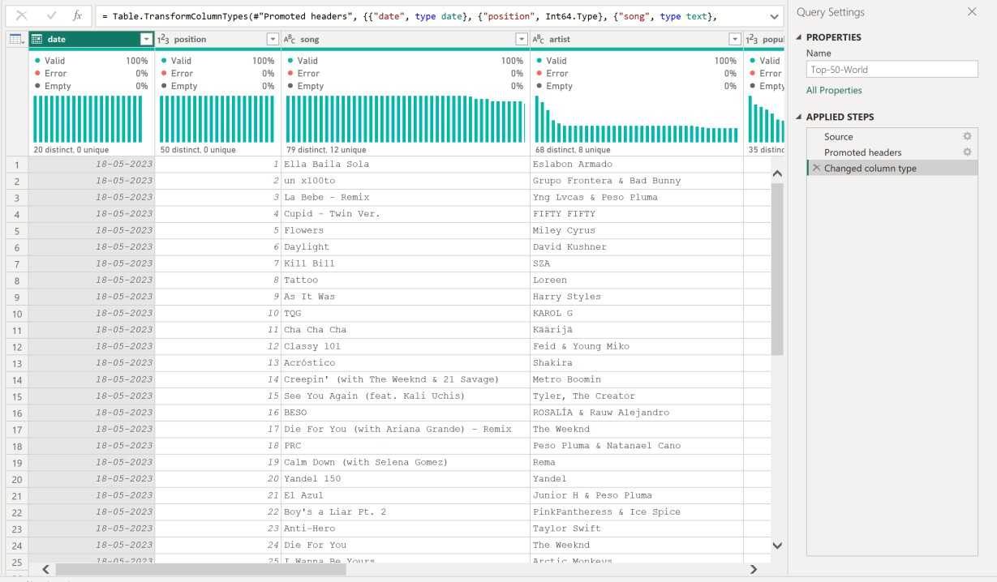

Model View
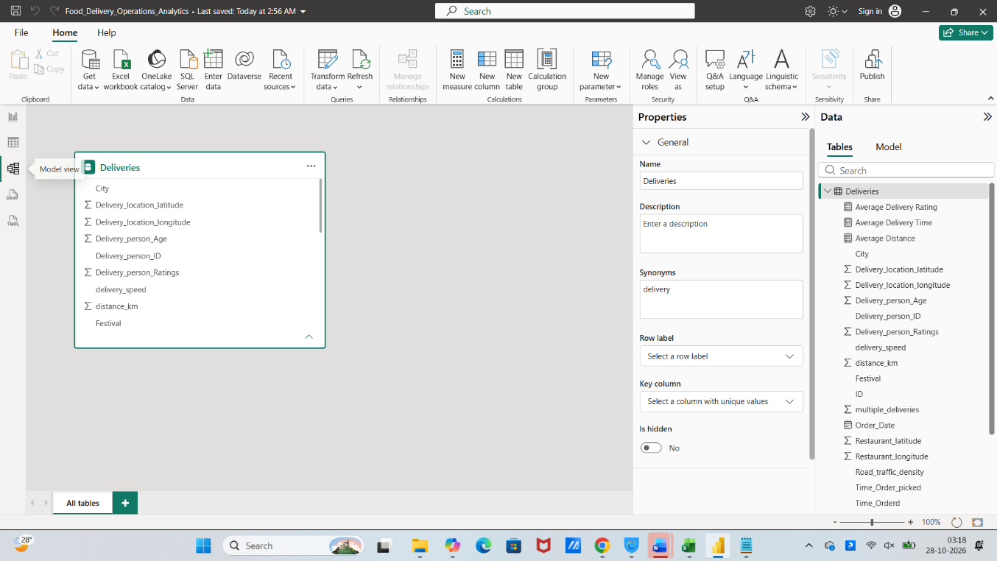

APPENDIX D: VISUAL DASHBOARD INTERFACE SPECIFICATIONS
D.1 Overview Page Visual Interface
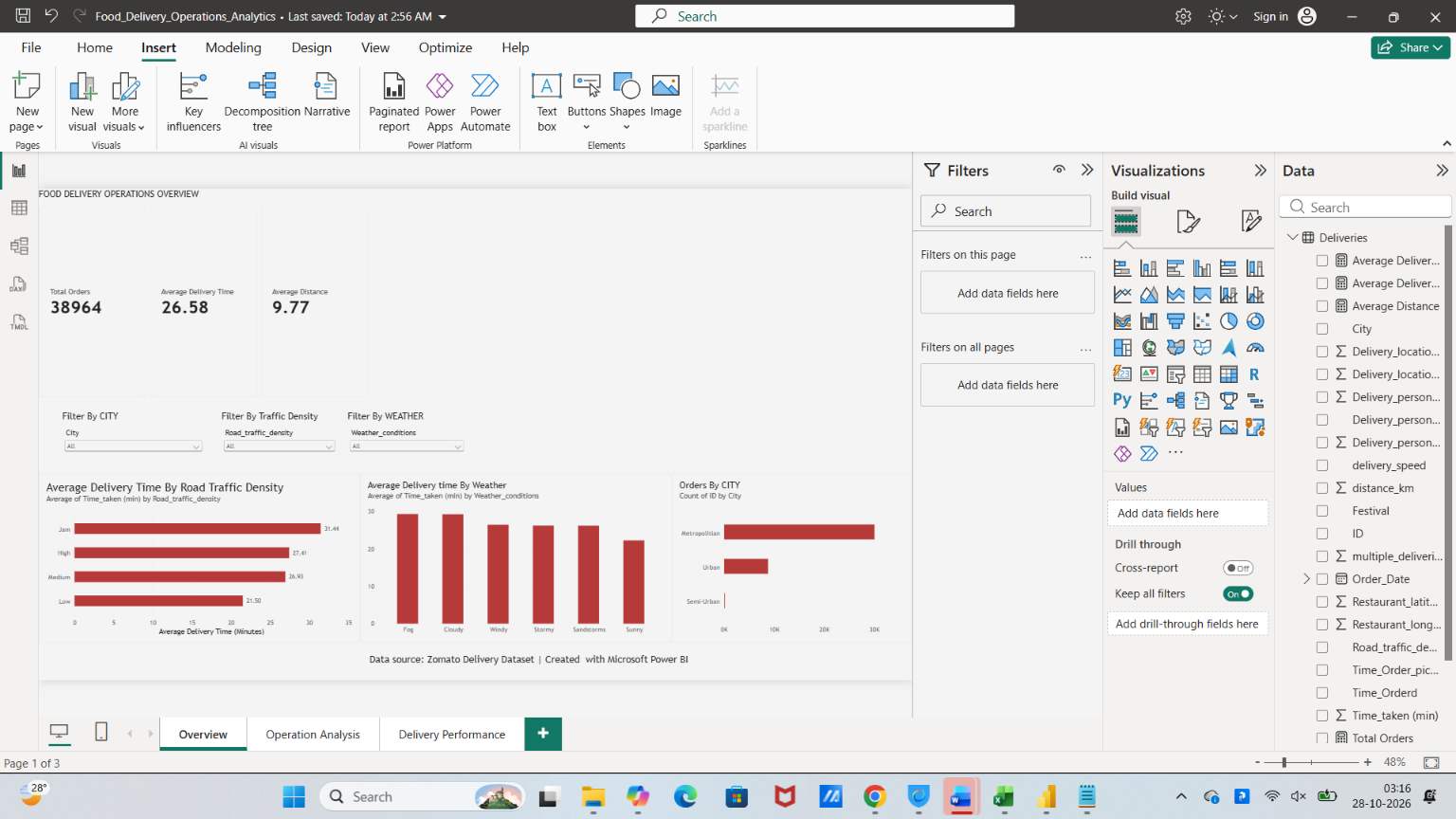

D.2 Operation Analysis Visual Interface
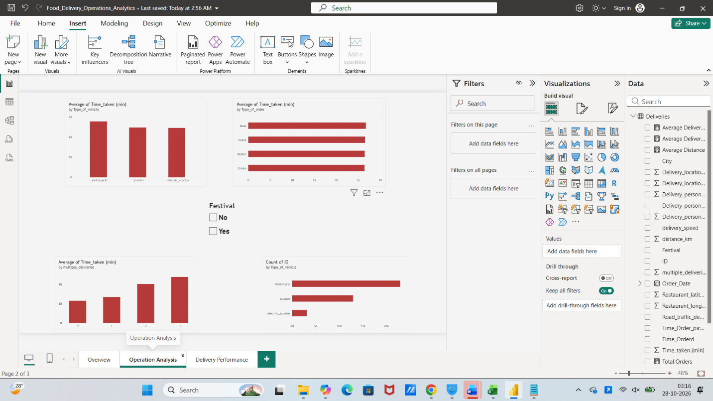
D.3 Delivery Performance Visual Interface
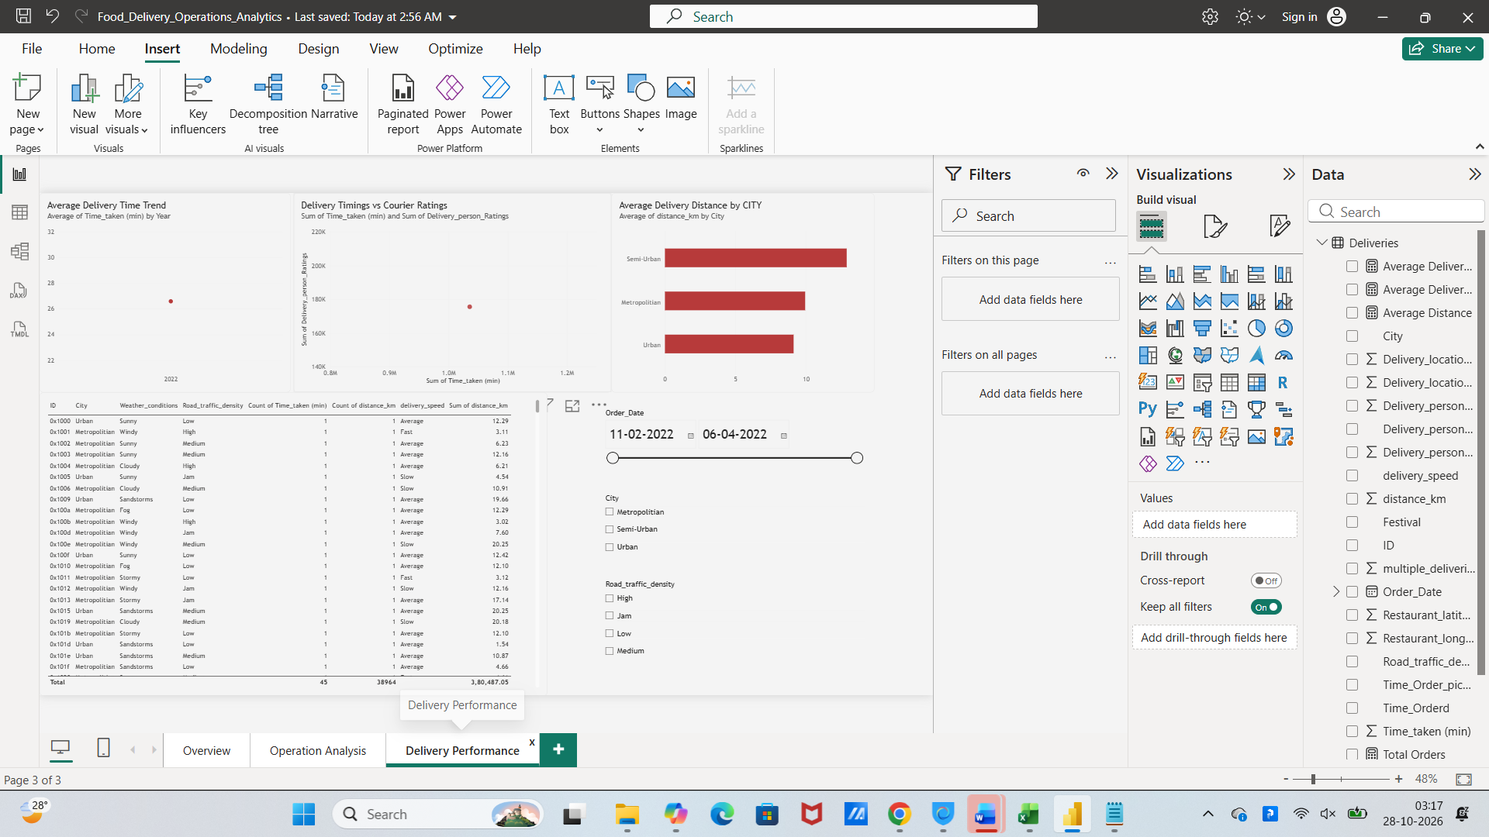

APPENDIX E: COMPARATIVE FILTER CONTEXT ANALYSIS

E.1 Cross-Filter Impact Matrix

Comparing operational metrics between the Unfiltered Baseline Context and the filtered Urban City Context illustrates the dynamic cross-filtering capabilities of Power BI Desktop:
Metric / Operational Dimension | Unfiltered Baseline Context | Filtered Urban City Context | Operational Delta / Impact
Active Slicer Selection | All Cities Selected | Urban City Slicer Active | Regional isolation.
Total Order Volume | 38,964 Orders | 8,782 Orders | Represents 22.5% of network volume.
Average Delivery Time (min) | 26.58 Minutes | 23.24 Minutes | Deliveries complete 3.34 min faster (-12.6%).
Average Distance (km) | 9.77 Kilometers | 9.12 Kilometers | Spatial routes are 0.65 km shorter (-6.7%).
Jam Traffic Avg Delivery Time | 31.50 Minutes | 28.50 Minutes | Heavy traffic delays drop by 3.00 minutes.
High Traffic Avg Delivery Time | 27.50 Minutes | 24.50 Minutes | High traffic delays drop by 3.00 minutes.
Medium Traffic Avg Duration | 26.20 Minutes | 23.00 Minutes | Medium traffic delays drop by 3.20 minutes.
Low Traffic Avg Delivery Time | 21.50 Minutes | 18.60 Minutes | Low traffic deliveries complete in 18.6 min.
Sunny Weather Avg Duration | 22.00 Minutes | 18.50 Minutes | Clear weather deliveries complete in 18.5 min.
Adverse Weather Avg Duration | ~26.20 Minutes | ~22.50 Minutes | Bad weather delays average 22.50 min.

